Full Stack Assignment

MODULE:1(SDLC)

1 What is software? What is software engineering

Ans:- Software is collection of information,instruction and data.

Software engineering is the branch of computer science that deals with the design,development,testing, and maintenance of software applications .

2 Explain types of software

Ans:- There are 5 types in software

1. System Software
2. Application Software
3. Programming Software
4. Driver Software
5. Middleware Software

1:- System Software

System software is a computer program that is design to run a computer’s hardware and application programs.

OS-Operating System

Ex. Linux, xbox

2:- Application Software

1. Mobile Application
2. Web Application
3. Desktop Application
4. Mobile Application

The Application run on the mobile platform

-> WhatsApp,Linkedin

2) Web Application

Web Application on the run all web browser

-> Firefox, Microsoft Edge

3) Desktop Application

Desktop application are used to perform some task on PC/Laptop

Microsoft Word, Notepad

3:-Programming Software

-> Programming software is use to communicate between human and machine.

->Turbo c , Bootstrap

4:- Driver Software

-> Driver Software every device connected to a computer needs at least one device driver to function

Ex. Audio Driver, Video Driver, Network Driver

5:- Middleware Software

-> Middle ware is software lies between an operating system and the application running on it

Ex. Database Middleware application server

3 What is SDLC? Explain each phase of SDLC

Ans:-

SDLC SOFTWARE DEVELOPMENT LIFE CYCLE

1:- PLANNING

The first phase of the sdlc is the project planning stage where you are gathering business requirements from your client or stakeholders.

2:- ANALYSIS

The SDLC is usually in use to the Analysis ,Planning

Architecture Design ,Development ,Testing and Maintenance

3:-DESIGN

Design Support team to the design to software UX UI designer

4:- IMPLEMENTATION

This phase is initiated after the system has been tested and accepted by the user.

5:- TESTING&INTEGRATION

Testing is to a group of software to the testing in individual components of the software are testing group

6:- MAINTENANCE

The maintaince phase of the software development life-

cycle is a users support team to the upgrad to software

4 What is DFD? Crate a DFD diagram on Flipkart

Ans:-DFD Stand for Data Flow Diagram use to a graphical representation of flow of data inside application.

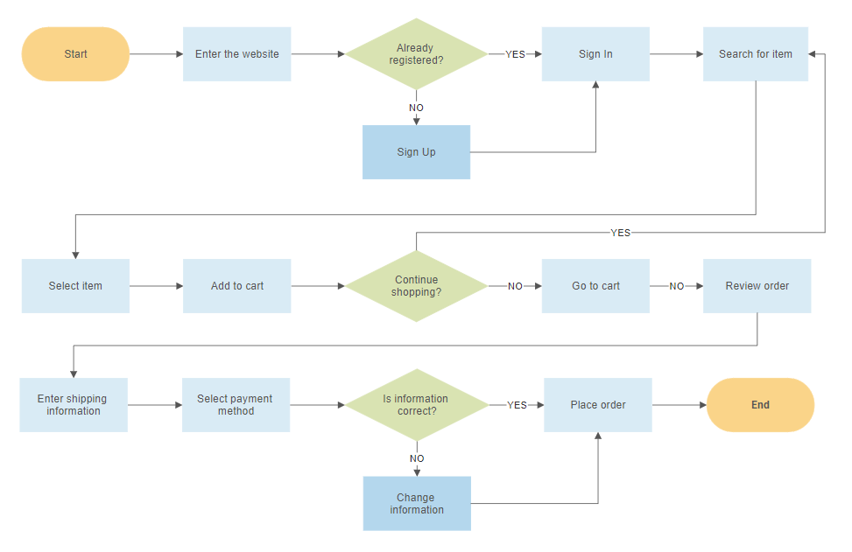

5 What is Flow Chart? Create a flowchart to make addition of two numbers

Ans:-Flow chart is use to show algorithm or process give step solution to the problem.

1 start Or End

2Process

Res=num1+num2

int number1,number2

3 input or output

If

Num1>num2

4 Decision Making

5 Flow lines

Create a flowchart to make addition of two numbers

Print Sum

Sum=Number1+Number2

Input Number 1, Number2

6 What is Use case Diagram? Create a use-case on bill payment on paytm

Ans:-

Use case diagram model the behavior of a system

Used to illustrate the functional requirements of the system and its interaction with external agents (actors)

